Incorporation of High Head Bypass into Trap and Haul Designs for Cougar Reservoir: A Hybrid Approach
Desired Outcome: A dedicated effort to design high head piped bypass for fish at Cougar Dam
  - Minimize fish handling
  - Real time fish passage (no holding time)
  - Concurrent with trap and haul design
  - Maintain the current schedule
Background
We are at the final stage of providing fish passage at Cougar Dam:
- The Water Temperature Control Tower (WTCT) became operational in 2005.
  - More normative water temperatures resulted in appropriately timed adult spring Chinook (ChS) returns to the South Fork McKenzie River and to the base of Cougar Dam.
- The Cougar Adult Fish Facility (ladder and trap) became operational in 2010, providing real-time upstream passage for adult salmon and bull trout, as well as other native migratory fish.
- Downstream fish passage is scheduled to be operational by 2023.
Early conversations investigated several options for how to achieve downstream fish passage at Cougar Dam, including trap and haul (the industry standard at the time), and volitional high head bypass through the dam or tower. Ultimately trap and haul was selected by the Corps as the preferred option for providing downstream fish passage; 90% designs for the Floating Screen Structure (FSS) (“collector”) are scheduled to be available for review in Fall 2018.
The need for a different approach
Portland General Electric (PGE) began operation of its River Mill surface collector in 2013 and its North Fork floating surface collector with downstream piped bypass fish passage in 2015 on the Clackamas River. Collection efficiency for Chinook at River Mill is the highest in the region. As a result of high collection efficiencies and successful bypass operation, ChS juvenile outmigration increased and, combined with recent upstream passage improvements, adult ChS returns to the Clackamas also increased at a time when McKenzie ChS returns remained flat. Successful fish passage is key to maintaining populations in perpetuity. With the Clackamas design:
- Juveniles outmigrate in real time without being subjected to holding tanks or handling
- Multiple size classes observed over a wider time frame representing passage when fish wanted to pass (multiple life history strategies increases resilience)
- NMFS supportive of PGE piped bypass passage approach
The current trap and haul design for Cougar fish collection and downstream passage includes holding, and multiple handling and fish transfer events before fish are delivered downstream of the dam, contributing to accumulated stress on the fish.
- For several years, ODFW research staff has reported on copepods in sampled reservoir fish.
- Copepod infestations typically increase during the summer to the point where fish captured in the Cougar Reservoir portable floating fish collector (PFFC) in fall are severely compromised.
  - Heavily copepod-infested fish collected from Cougar Reservoir and subjected to a swimming challenge could not survive the study to completion (Herron et al., 2018).
  - Fish collected from the PFFC in the fall and handled by experienced Corps fish biologists experienced high rates of mortality not observed earlier in the season when copepod infestations were lower (Greg Taylor, pers. comm., 2018)
- Research by OSU’s Carl Schreck and others suggest cumulative effects of stressors such as increased water temperatures and parasites, in concert with physiological changes, can negatively affect survival.
Given the vulnerability of copepod-infested fish to additional stressors, ODFW is advocating for minimizing handling and holding fish as part of the engineered passage design.
Conceptual Model for Hybrid High Head Bypass Fish Passage Design at Cougar
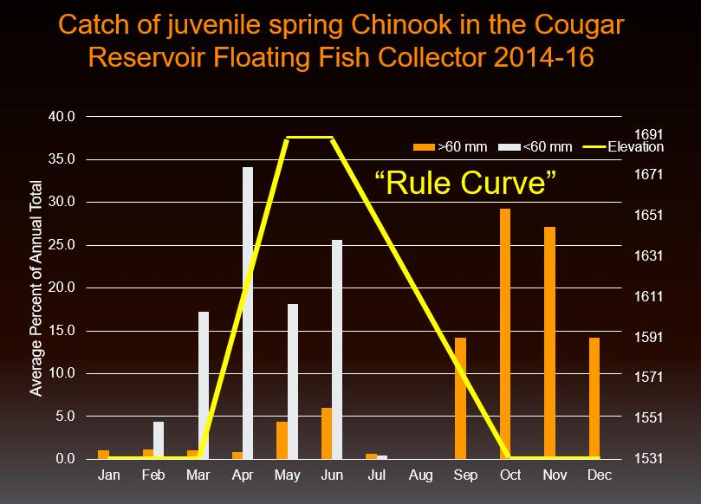
- Draw down Cougar Reservoir beginning in late summer (earlier than current operations) and hold at a low flood control elevation (1532’) until late spring (later than current operations) (Figure 1).
  - Compatible with rule curve
  - Pass inflow except as needed to achieve flood control through the fall and winter months
- Include a portal in the rear of the current FSS design to incorporate a bypass pipe. Bypass will channel fish through a bored hole in the natural rock west of Cougar Dam, conveying them below the dam in a non-pressurized pipe (Figure 2).
Figure 1. Cougar Reservoir PFFC catch of juvenile spring Chinook, 2014-2016, overlaid by reservoir elevation during proposed high head bypass operations for fish passage.
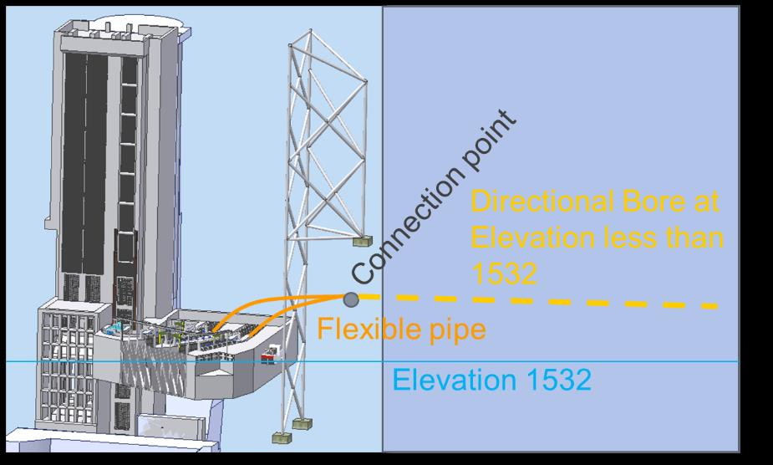
- The reservoir will remain available to capture high flow events throughout the high head bypass “season” by including a quick disconnect feature from the FSS to the bypass pipe.
- During the fall through winter and late spring (peak migration), collected fish immediately exit the FSS via the non-pressurized high head bypass pipe and are released downstream.
- Fill reservoir in late spring for flow augmentation season; collected fish are transferred downstream via trap and haul until high head bypass is resumed in fall coincident with the reservoir drawdown.
Figure 2. Conceptual design of flexible pipe connection from Cougar FSS to bypass pipe bored through rock.

References:
Herron, C.L, N. Ruse, M.L. Kent, C.B. Schreck. 2018. Parasitic copepods may be important freshwater population regulatory factors by impairing swimming, stress resistance, and being a vector for pathogens. Presented at the Willamette Fisheries Science Review, The LaSells Stewart Center, OSU.

